Edgar Arroyo

6/18/2024

Module 5.2 Assignment: MYSQL Functions

1. CONCAT

The CONCAT function might be used when looking at data from a table or database and you need to pull from multiple columns. With the CONCAT function, you c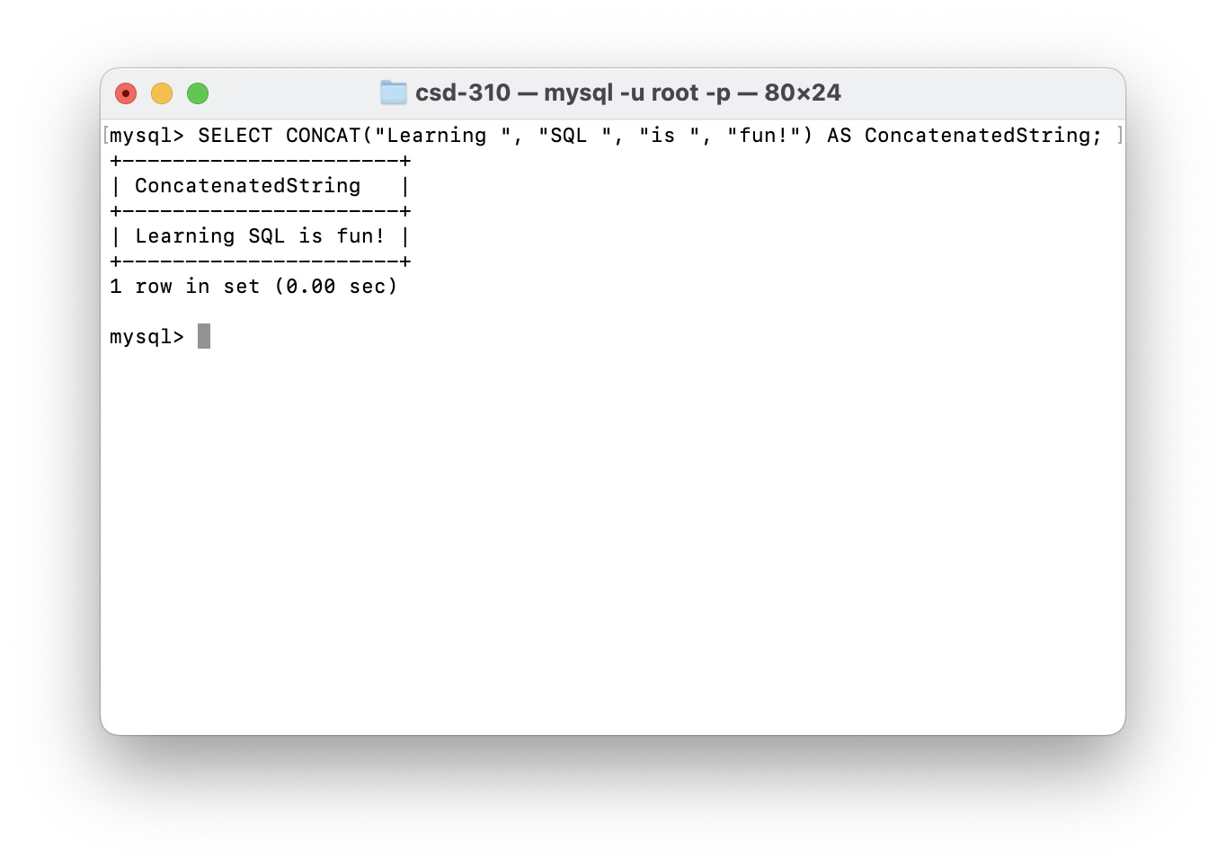an concatenate multiple columns and view it as one column with an alias.

1. GREATEST

The GREATEST function might be used when looking for the highest value within a column of a table or a database. This also works with strings.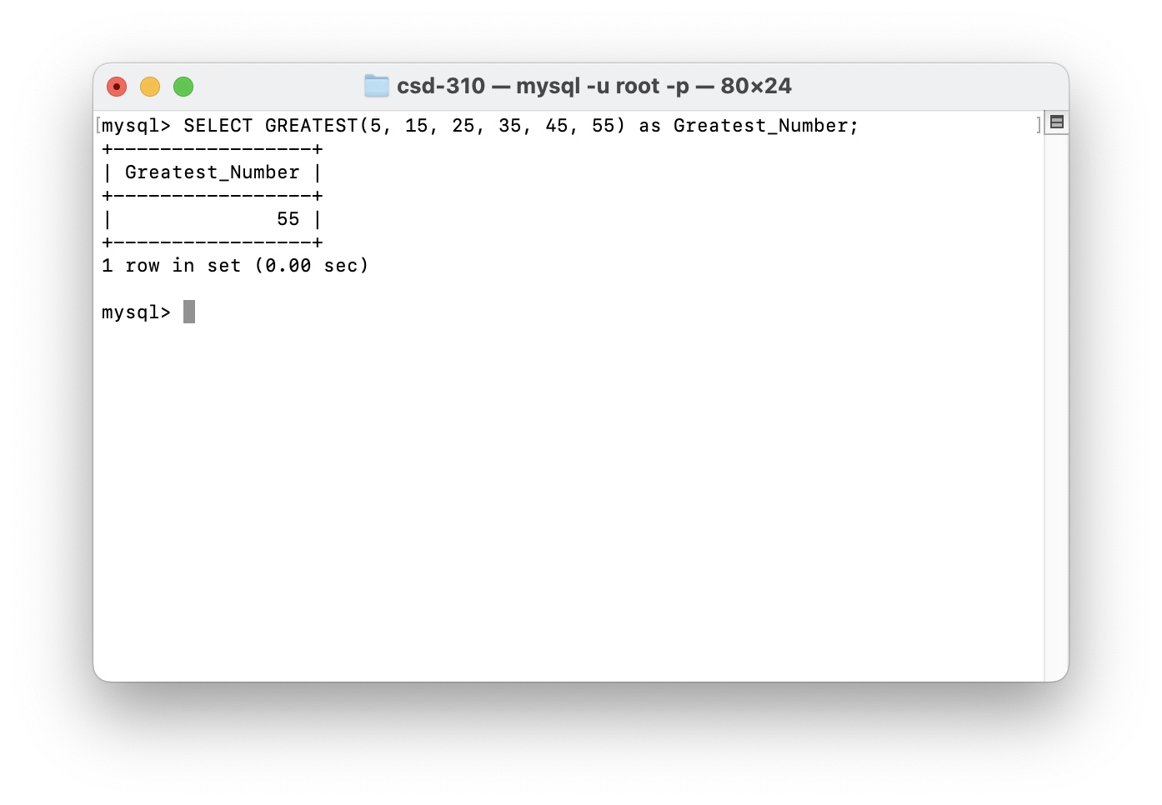

1. DATEDIFF

The DATEDIFF function might be used when taking two dates and calculating the amount of days that have passed since the first date to the second date.; such as seeing when was the last time someone logged in to a site or service.